Operating Systems Lab Assignment 1-
Task1- Process Creation Utility
Write a Python program that creates N child processes using os.fork(). Each child prints:
- Its PID
- Its Parent PID
- A custom message
The parent should wait for all children using os.wait().
Sol.-
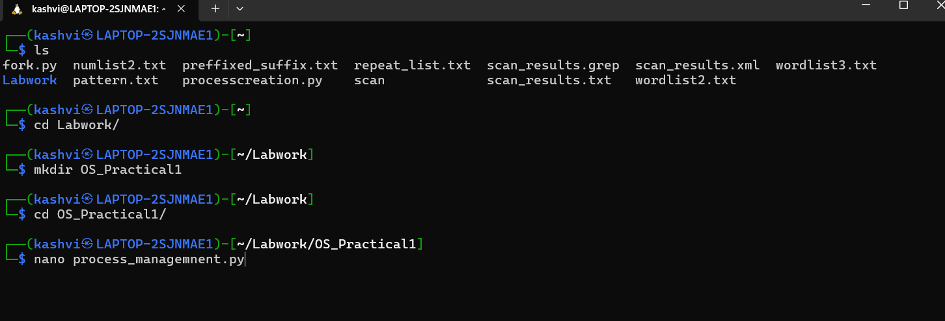
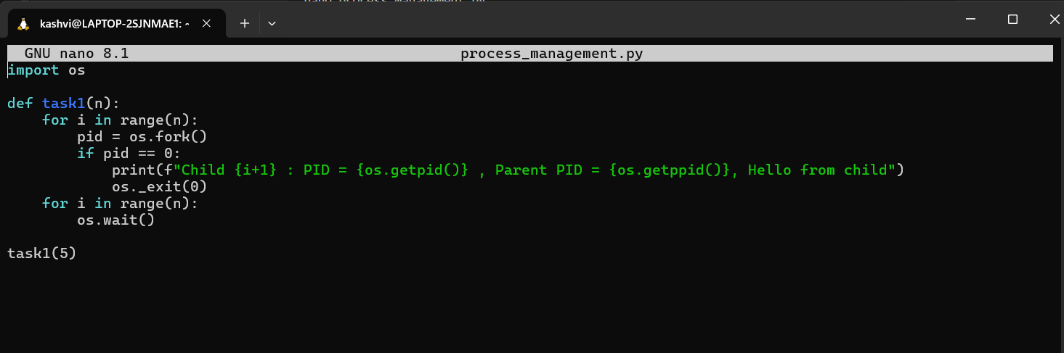
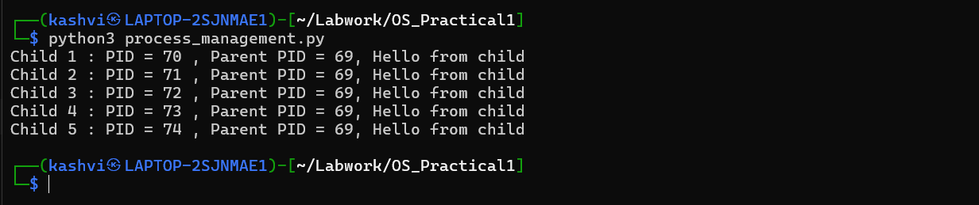

Task 2- Command Execution Using exec()
Modify Task 1 so that each child process executes a Linux command (ls, date, ps, etc.) using os.execvp() or subprocess.run().
Sol.-
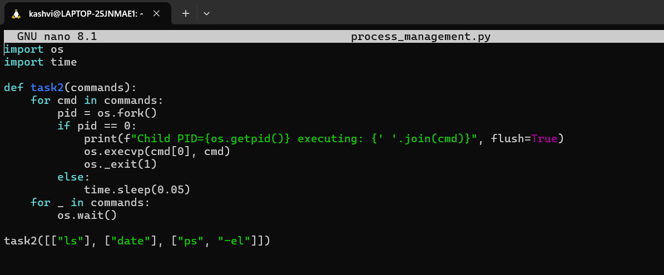
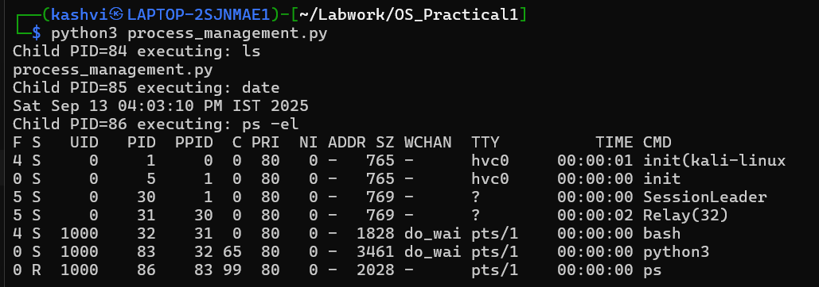

Task 3 - Zombie & Orphan Processes
Zombie: Fork a child and skip wait() in the parent.
Orphan: Parent exits before the child finishes.
Use ps -el | grep defunct to identify zombies.
Sol.-
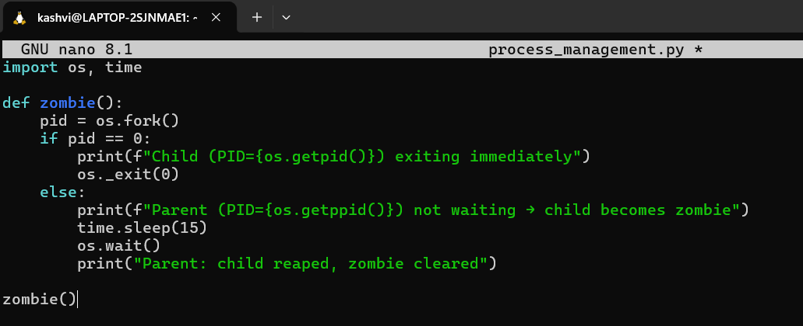
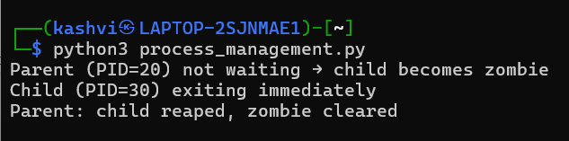
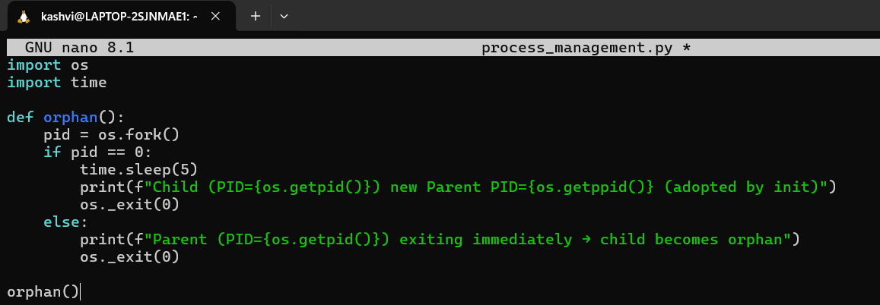
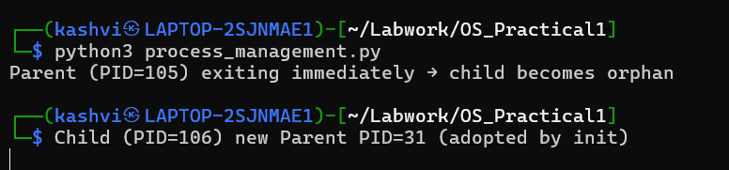

Task 4 - Inspecting Process Info from /proc
Take a PID as input. Read and print:
- Process name, state, memory usage from /proc/[pid]/status
- Executable path from /proc/[pid]/exe
- Open file descriptors from /proc/[pid]/fd
Sol.- -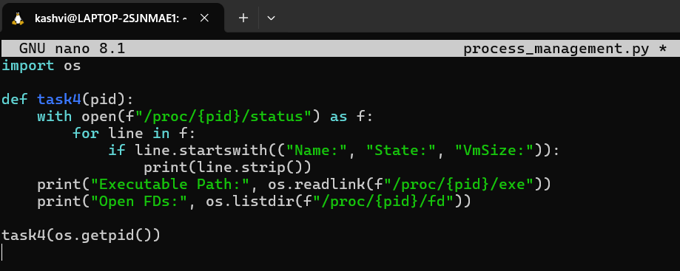
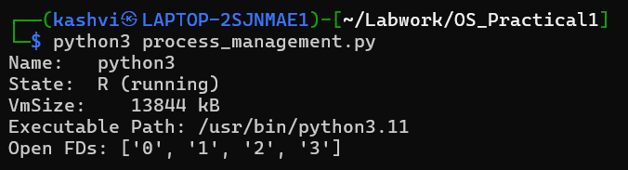

Task 5 - Process Prioritization
Create multiple CPU-intensive child processes. Assign different nice() values. Observe and log execution order to show scheduler impact.
Sol.-
